CPS209 Assignment 2:

Grocery Store Simulator Part II

Due Date: Fri., Apr 13 11:59pm

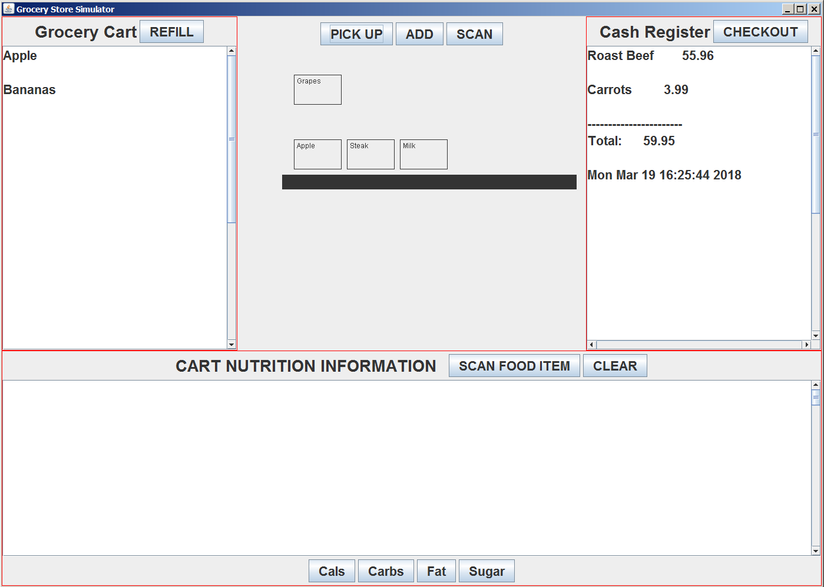

You are to extend the Grocery Store Simulator program from assignment 1. This programming assignment will increase your knowledge of objects and classes, inheritance, interfaces, GUIs, File I/O and Exceptions, Stacks, List Iterators, Maps, Linked Lists, Graphics and Mouse Event Handling. You must do this assignment alone – no groups. Do not attempt to find source code on the web for this assignment. It will not help you and you risk extremely serious consequences. Your program will be checked for plagiarism. Begin designing and programming early! This assignment is worth 10 percent of your mark. If there is some part of the assignment you do not understand, please see me (or email me) or ask me in the lecture as soon as possible and I will clarify the issue.

Program Functionality Requirements:

Please review the two example programs in the GUI documents folder: I am providing the simple viewer class for your program called GroceryStoreViewer. Please use it and submit it with your files. I will also be posting a solution to assignment 1 as soon as all assignment I submissions are in (including late submissions). You are permitted to use my solution as a base for your assignment 2 if you prefer, instead of your own. Below are the main classes for your assignment and suggested list of methods and variables. Some variables are required so please read carefully. I strongly suggest you build your program in pieces. Get one piece compiled and working before working on the next piece. Read the marking scheme below and use it as a guide.

Class GroceryItem: same as in assignment 1.

Extend and modify class GroceryCart.

Replace your array list of grocery items with a Stack. This means method removeTopItem() and addItem() should now remove and add from a Stack of GroceryItems. Also, use a ListIterator when going through all the items in your grocery cart for the nutrition scanner.

Method fill() will now be filling up the cart based on items in a text file “groceryItems.txt”. You must open the file and read it one line at a time. Each line (a String) will describe a grocery item. You will be interpreting the words in the line and building a new grocery item and adding it to the cart (i.e the Stack or GroceryItems). In your GroceryStoreFrame class where you call the fill() method when the REFILL button is pressed, you will be handling any exceptions thrown by the fill() method. Basically, if an exception occurs, print out an appropriate error message to the console and exit the program. Your program should catch IO exceptions and exceptions like NumberFormatException etc.

Here are examples of the format of each line in the groceryItems.txt file. You must use this format! The TA will be using his own groceryItems.txt file to test your code! NOTE: there are no empty lines in the file even though it appears like there are below.

111 Bananas 3.25

222 Apple 2.99

333 Grapes 4.72

222 Apple 2.99

435 Meat Steak 11.99 2

654 Dairy Milk 2.99 2

725 Carrots 3.99

435 Meat Roast Beef 13.99 4

Basically, each line starts with the food code (an integer - use any integers you want). Then a delimiter (e.g. a space or spaces or tabs etc.) followed by the label (a String), then another delimiter, then the price (a double). If the item is a subclass such as Meat or Dairy then the label string begins with the keyword Meat or the keyword Dairy, followed by a delimiter then followed by the label then price then another integer representing an amount (e.g. weight of meat). NOTE: your program must be able to handle a label that may consist of more than one word! In my example, “Roast Beef” is two words but a label may have any number of words.

Class CashRegister. Same as assignment 1.

Nutrition Scanner: same as assignment 1

class NutritionChart:

This class should now contain a map between food codes and a FoodType object instead of an array list. That is, use the food code as a key and the method FoodType getFoodType(int foodCode) will use a HashMap/TreeMap to find the FoodType object. Also, fill the chart from a text file called “nutrition.txt” using a format (on each line of the file): food code, label, measure, calories, sugar, fat, carbs. Note: everything is an integer except the label which is a string.

Class ConveyerBelt: This is a new class and it extends JPanel (or JComponent). You will make an object of this class and place it in the center part of the scanItemsPanel, which is in the center part of grocery store frame. The ConveyerBelt class will override the paintComponent(Graphics g) method inherited from JPanel or JComponent and you will be drawing a conveyer belt (a solid rectangle) and grocery items on this belt.

Class LinkGroceryItem: Inside the ConveyerBelt class you MUST HAVE an inner private class called LinkGroceryItem. This class will be used to keep GroceryItem objects in a “linked list” that your code will manage (i.e. you are not allowed to use the Java class LinkedList). This inner class has a variable called gitem of type GroceryItem and a variable called next of type LinkGroceryItem. This class also has a Rectangle variable called box (i.e. a reference to a Rectangle object). Here is a description of the methods of the inner class LinkGroceryItem

Create a constructor method that takes as parameters a reference to a grocery item and a reference to the next LinkGroceryItem object in the linked list and initialize the gitem and next instance variables, repspectively. Create a rectangle object in a predefined location and set box to point to it.

setLocation(int x, int y): sets the location of the box rectangle object of this LinkGroceryItem

boolean intersects(LinkGroceryItem item): given the box rectangle object from item, uses the Rectangle class intersects() method to see if it intersects this.box Returns true if it does, false otherwise.

void draw(Graphics2D g2): draws the box and the label string stored in the gitem object. Then call the setLocation() method of the next LinkGrocerytem (if it exists) to set its location relative to this LinkGroceryItem object and then call its draw method.

The ConveyerBelt class will have an instance variable called first. This variable keeps track of the first LinkGroceryItem object. It should set the location of the box inside the object to a fixed location

The ConveyerBelt class should have an instance variable called pickedUpItem - a reference to a LinkGroceryItem object. This will be set when the PICKUP button is pressed. Initially it is null. See below for a description of how to use it.

ConveyerBelt class should also have the following methods:

private int numItems(): goes through your linked list of LinkGroceryItems (starting from first) and counts the number of LinkGroceryItem objects. Return this number.

public void addItem(): called when the ADD button is pressed. It uses the pickedUpItem object and adds it to the front of your linked list of LinkGroceryItems. Calls repaint() to redraw everything. Hint: make sure pickedUpItem is not null! Nothing should happen if the conveyer belt is full (in mine, 5 LinkGroceryItems is the capacity)

public GroceryItem removeItem(): goes through your linked list of LinkGroceryItem objects and finds the last one. Removes it from the linked list, calls repaint() and returns a reference to gitem stored inside the LinkGroceryItem. The SCAN button calls this method.

public boolean setPickedUpItem(GroceryItem item): called when the PICKUP button is pressed. Creates a new LinkGroceryItem object passing in the reference to the GroceryItem object (i.e. gitem will be set to point to it), and then sets pickedUpItem to point to this new LinkGroceryItem object. Calls repaint(). Note: if pickedUpItem is not null, do nothing. Ask yourself why? See the video.

public void paintComponent(Graphics g): draws the pickedUpItem, draws the linked list of LinkGroceryItems, draws the conveyer belt rectangle

In the constructor method of class ConveyerBelt add code to implement the MouseListener interface and the MouseMotionListener interface. This code should allow you to select the pickedUpItem object and drag it around. If you drag it such that the box rectangle intersects the box rectangle of a LinkGroceryItem object on the conveyer, you insert the pickedUpItem object into the linked list after this LinkGroceryItem object. Nothing should happen if the conveyer belt is currently full.

Replace the SCAN GROCERY ITEM button at the north part of the scanItemsPanel with 3 buttons: PICKUP ADD SCAN. PICKUP removes a GroceryItem object from the cart, creates a LinkGroceryItem object and sets pickedUpitem reference to it. Hint: check to ensure pickedUpItem is currently null. ADD button calls conveyerBelt object addItem() method and SCAN calls conveyerBelt object removeItem() method and hands the item to the cash register as before.

Grading (Out of 10 marks)

Class GroceryCart modifications working correctly as described above | Maximum 5 marks out of 10
Everything above plus modifications to class NutritionChart | Maximum 6 marks out of 10
Everything above plus class ConveyerBelt PICKUP, ADD, and SCAN buttons work. A proper linked list of LinkGroceryItem objects is created and maintained and properly drawn according to the description above. | Maximum 8.5 marks out of 10
Everything above plus addition of the mouse handling functionality to allow the insertion of the pickedUpItem anywhere in the linked list of LinkGroceryItems. | Maximum 10 marks out of 10

Submitting Your Assignment
- NOTE!!!!!!: Include the GroceryStoreViewer class I gave you in your submission. The TAs simply download all your files, compile and run. If GroceryStoreViewer is missing, they may think your program does not compile.
- Use D2L to submit your assignment.
- Inside each of your “.java” files have your name and student id as comments at the top of the file. Make sure your files can be compiled as is without any further modification!!
- Include a README.txt file that describes what aspects of your program works and what doesn't work (or partially works). If your program does not compile, state this.
- Place all your “.java” file(s) and README.txt file into an archive (zip or rar archiving format only).
- Open your archive and make sure your all your files are there.
- Do not include ".class" files!!!!
- Once everything is ready, submit it.

